Data Types in Java
Java has two categories of data:
- Primitive Data Type: such as boolean, char, int, short, byte, long, float and double
- Non-Primitive Data Type or Object Data type: such as String, Array, etc.

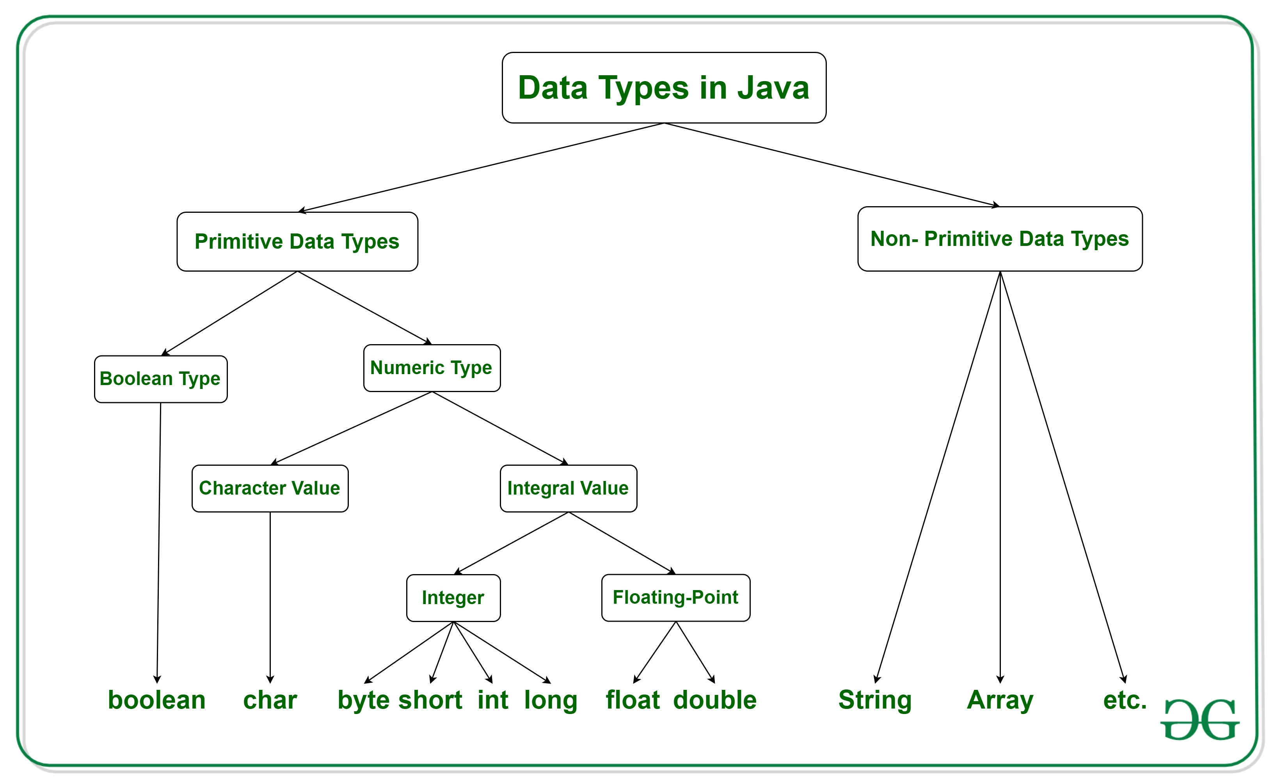

Java Primitive Data Types
Any data type built-into a programming language is called ‘primitive’ data type (the word itself betrays its meaning). Built-in data types are the basic building blocks of a programming language. It is often possible to combine them to create composite data types. The basic behavior of a primitive data type itself, however, cannot be modified (it is, after all, something primitive to the language – like the human Id).
There are eight primitive data types in Java. These are as follows:
1. Byte: A byte, is one of the most basic units of memory made up of 8 individual bits. Byte data types in Java have the following characteristics:
- Minimum Value: -128 (2^7)
- Maximum Value: 127 (2^7-1)
- Default Value: 0
Examples:
byte x = 56;
byte y = 68;
Thus, you can save numbers between -128 and 127 (inclusive) in a byte. Bytes, because of their size, are useful for storing small data in large arrays.

2. Short: A short is twice the size of a byte, i.e. it is made up of 16-bits. Its chief characteristics are:
- Minimum Value: -32,768 (2^15)
- Maximum Value: 32,767 (2^15-1)
- Default Value: 0
Examples:
short x = 9870
short y = -635
Like bytes, short types are useful alternatives to int (see below) data types, particularly if your data falls within the specified range. As with byte, using short also improves code readability, besides saving memory.
3. Int: An integer is four times the size of a byte (i.e. it is made up of 32 bits). It is one of the most commonly used data types in Java.
- Minimum Value: -2,147,483,648 (2^31)
- Maximum Value: 2,147,483,647 (2^31 – 1)
- Default Value: 0
Examples:
int x = 150000
int y = -2004320
As the most easily understood data type, you will use int a lot in your code.
4. Long: A long data type is twice the size of an integer, i.e. it is made up of 64-bits. It’s chief characteristics are:
- Minimum Value: -9,223,372,036,854,775,808 (2^63)
- Maximum Value: 9,223,372,036,854,775,807 (2^63 – 1)
- Default Value: 0
Examples:
long x = 6778005876543
long y = -554233254242
You’ll use long only if you encounter data that doesn’t fit within the int range (which will be rare).
5. Float: In programming, any decimal or fractional value is called a ‘float’. If there is a decimal after the number, it will be classified as a float. In Java, a float is made up of 32-bits IEEE floating points*.
The minimum/maximum value of float is not the same as that of the int data type (despite both being made of 32-bits). we use float for saving decimal values.
Examples:
float x = 2.321
float y = 1.234
*The float value range depends on the IEEE standard classification for floating point numbers.
6. Double: Double is a data type that is twice the size of a float. I.e. it is made up of 64-bit IEEE floating points.
As with float, discussing the minimum/maximum value of double data type is beyond the scope of this article. What you should know is that double is a much more precise type than float.
Examples:
double a = 1.245240
double y = 12.2232
7. Char: Char data type refers to a single 16-bit Unicode character. Unicode is a computer industry standard for representing text related data. This includes alphabets, symbols ($, &, *, #, @, !, etc.), and special figures such as ¢, £, ¥, etc. The Unicode character set includes over 110,000 characters covering more than 100 language scripts.
In other words, any data besides numbers goes into the char data type.
Default value is single space character.
Examples:
char name = ‘John’
char country = ‘USA’
8. Boolean: Boolean is the smallest data type in Java, i.e. it is made up of only one bit. Thus, a Boolean data type can have only two values – 0 (or False) and 1 (or True).
Example:
boolean x = true
boolean y = false
default value : boolean =false
(Tip: ‘True’ and ‘False’ written above are not strings. Do not enclose them within quotes as we did with the char example above)

Default value is provided by JVM
For class ,objects,string default values are null
Non primitive data type:
Int x=20;
String : The String data type is used to store a sequence of characters (text). String values must be surrounded by double quotes:

Example

String str = "Hello World"; //no error

System.out.println(str);

If String is a class ,why we r taking it as a datatype?

Ans : every class is a datatype and is called user defined datatype.

PRIMITIVE | SIZE IN BYTES | RANGE
Byte | 1 byte | -128 to 127
Short | 2 byte | -32768 to 32767
int | 4 bytes | -2147483648 to 2147483647
long | 8 bytes | -2 ^{^63} to 2 ^{^63} -1
float | 4bytes | -3.4e38 to -1.4e-45 and  3.4e38 to 1.4e-45
double | 8 bytes | -1.8e308 to -4.9e-324 AND  1.8e308 to 4.9e-324
String | 16 bits per char | Not applicable
char | 2 bytes | 0 to 65535
boolean | 1 bytes | True or false
